RHYTHM FOLLOWING FLASHING LIGHTS

ABSTRACT

The aim of this project is to develop a rhythm following flash led’s which blinks following the rhythm of the music.
The light which glows according to the rhythm of the music is interesting to watch. Researchers founded that the rhythmic lights speeds up the brain waves that develops the higher concentration levels. This project is implemented in such a way that the lights (LED’s) glow according to the music.
The rhythm following lights can be achieved by this system. This system uses a microphone through which, the audio input is picked up and amplified. Then this amplified signal triggers the sequence of LED’s through an intermediate circuit. Hence the flashing of the LED’s is done when an audio input is constantly changing its beat. So a Beautiful scenario of the changing LED’s can be viewed with the changing beat of the music.
Further the project can enhanced by using triacs and opto-isolators to use high power lamps in place of LEDs.

BLOCK DIAGRAM

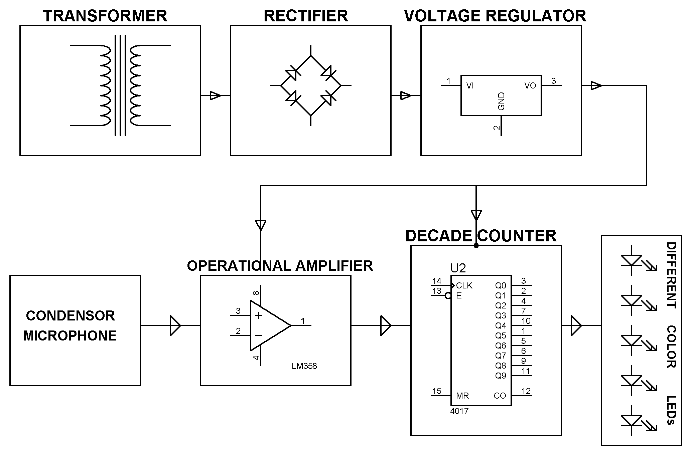
HARDWARE REQUIREMENTS:
Decade counter IC, OPAMP, Transistors, Potentiometers, Condenser Microphone, diodes, LED’s, capacitors, resistors.

